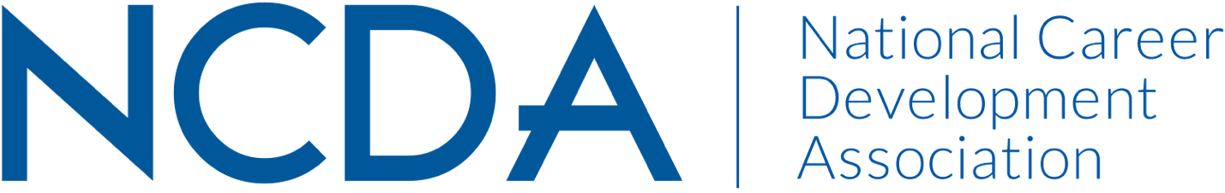

GOVERNMENT RELATIONS COMMITTEE AND
SUBJECT MATTER EXPERTS (SME) FOR ADVOCACY

The following individuals are highly experienced and qualified in Career Development standards and implementation. They can be contacted for content, testimony and feedback in the following areas:

AREA | NAME | ROLE WITH NCDA | PROFESSIONAL ROLE | OTHER
Workforce Dev/CTE/ Apprenticeship
 | Diana M. Bailey | Gov’t Relations Cmte co-chair, Brain Trust & Leadership Academy Dev Cmte | Consultant | TA Coach
 | Natalie Kauffman | Cmte member of Awards (co-chair), Global Connections & Gov’t Relations | Private Career Practitioner | Transition Consultant | Federal Job Coach & Trainer
 | Charles Lehman | Veterans Cmte co-chair | Labor Economist | Workforce Board Administrator,  Employment & Economic Information Center NM
 | Mike Marlowe | Gov’t Relations Cmte co-chair
AREA | NAME | ROLE WITH NCDA | PROFESSIONAL ROLE | OTHER
Vets/TAP

 | Emily Kegerreis | Veterans Cmte co-chair | Consultant
 | Charles Lehman | Veterans Cmte co-chair | Labor Economist | Workforce Board Administrator,  Employment & Economic Information Center NM
 | Ashley Moore | Gov’t Relations & Veterans Cmte member | Current High School Counselor & immediate former Graduate Fellow, GW Office of Military & Veteran Student Services
Higher ED

 | Niel Carey | Brain Trust & Gov’t Relations Cmte member | NCDA Executive Director Emeritus
 | Dr. Rebecca Dedmond | Brain Trust, Counselor Educator Academy co-chair & Gov’t Relations Cmte member | Director, MA in School Counseling  Associate Professor, Counseling and Human Development  Director, Freshman Transition Initiative  GW
 | Dr. Kathy Evans | President Elect-Elect | Associate Professor,  Counselor Education  University of South Carolina
 | Natalie Kauffman | Cmte member of Awards (co-chair), Global Connections & Gov’t Relations | Private Career Practitioner | Transition Consultant | Federal Job Coach & Trainer
 | Lakeisha Mathews | Trustee Constituency: Higher Education Career Counselors & Specialists | Director, Career & Professional Development Center, University of Baltimore and owner, Right Resumes & Career Coaching, LLC
 | Dr. Spencer Niles | President Elect | Dean for the School for Education, The College of William & Mary
 | Dr. Lisa Severy | ACA Governing Council | Director of Career Services, University of Colorado Boulder
 | Paul Timmins | President | Director of Career Services, College of Liberal Arts, University of Minnesota
AREA | NAME | ROLE WITH NCDA | PROFESSIONAL ROLE | OTHER
K-12

 | Niel Carey | Brain Trust & Gov’t Relations Cmte member | NCDA Executive Director Emeritus
 | Dr. Rebecca Dedmond | Brain Trust, Counselor Educator Academy co-chair & Gov’t Relations Cmte member | Director, MA in School Counseling  Associate Professor, Counseling and Human Development  Director, Freshman Transition Initiative  GW
STILL awaiting confirmation | Mary Ellen Earnhardt | 2018 NCDA Hoyt Career Educator Practitioner Award winner & Reviewer for NCDA’s CSCDA | Educational Program Representative, 21st Century Community Learning Ctr, MT Office of Public Instruction
 | Celeste J. Hall | NCDA Trustee for School Career Counselors & Specialists constituency | Career Coach Specialist, Workforce Development Services, Virginia Community College System
 | Ashley Moore | Gov’t Relations & Veterans Cmte member | Current High School Counselor & immediate former Graduate Fellow, GW Office of Military & Veteran Student Services

For contact information for these NCDA SME, contact Jason Ortega jortega@lobbyit.com or Diana M. Bailey, GR Co-Chairperson dibailey@comcast.net

