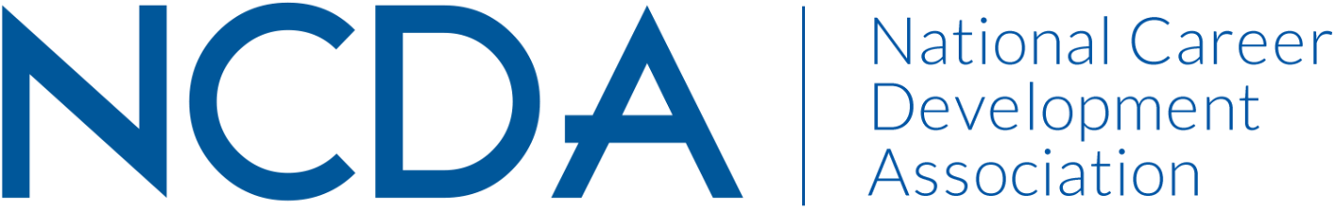
Annual Report

AWARDS COMMITTEE – Sep 2020

Board Liaison
Charles Lehman, charlesj.lehman@gmail.com

Continuing Co-Chair New Co-Chair (as of October 2020)
Jody Patterson Amanda Cox
Associate Director, Career Exploration Associate Director, Career Education
& Development and Professional Connections
Kent State University University of Illinois at Urbana-Champaign
330-672-8320 217-333-0820
jrpatter@kent.edu aacox@illinois.edu

Exiting Co-Chair (as of October 2020)
Sandra Sylvestre
Assistant Director of Career Development
Hiatt Career Center, Brandeis University
781-736-3618
ssylvest@brandeis.edu

List Committee Members (no contact information required):

- Carmen Croonquist
- Andra D’Amico
- Darren Gregory
- Michael Stebleton
- Erica Stallings
- Karol Taylor
- Kristina Wright
- Sheri Young
- Marie Smith
- Jeremiah Wong

Activities Since Mid-Year Report (March 2020)

- Collaborated with web editor to provide compiled information from award packets to support her article to celebrate 2020 winners
- Proposal subcommittee accepted invitation to submit conference session as a prerecorded conversation; updated plan to accommodate new situation without audience participation. Recorded and submitted session for virtual July conference
- Provided suggestions to NCDA on ways to celebrate 2020 winners considering change from in person to virtual conference
- Extended timeline for subcommittee working on enhancing the winner experience due to Covid 19 circumstances and time constraints
- Continued process improvement by review and update of Award Category Co-Lead and State Lead responsibilities paying special attention to improvements in the winner notification process
- Created new guide for co-chairs with responsibilities and timelines
- Held first virtual committee meeting for 2021 Awards, shared minutes and created plan for Oct call
- Selected Award Categories and State leads; established timeline for outreach efforts
- Established small working group to brainstorm, develop and submit a presentation for 2021 Conference
- Government Relations Committee will submit article for fall Career Convergence – due to election year
- Outgoing-chair – Sandra – created onboarding document to share with new co-chair – provides time commitment information and co-chair calendar
- Secured new co-chair – Amanda Cox (information at top)

Projected Plan through fiscal year end (September 30th)

- Newly-formed Award Category Co-Lead groups will connect before October meeting to review respective award descriptions and create plan for marketing and outreach
- Begin tailored marketing plan with State CDA Leaders, members within non-chartered states and International members
- Continue work on enhancing winner experience: research peer practices for award submissions to help evaluate our process; gather ideas to enhance notification and celebration
- Evaluate last year’s pilot attempt at using personalized form letters for winner notification and determine takeaways for 2021 award cycle
- Connect with HQ on updating winner seals for 2021
- Create tailored marketing plan in collaboration with HQ including member updates and email to all members
- LinkedIn marketing video created by Awards Committee Member, Marie Smith – committee members will use to market value of nominations and Awards Committee involvement
- Work with new co-chair to adapt on-boarding sheet for all committee members – can be shared when questions arise in recruiting process for new members

