National Career Development Association
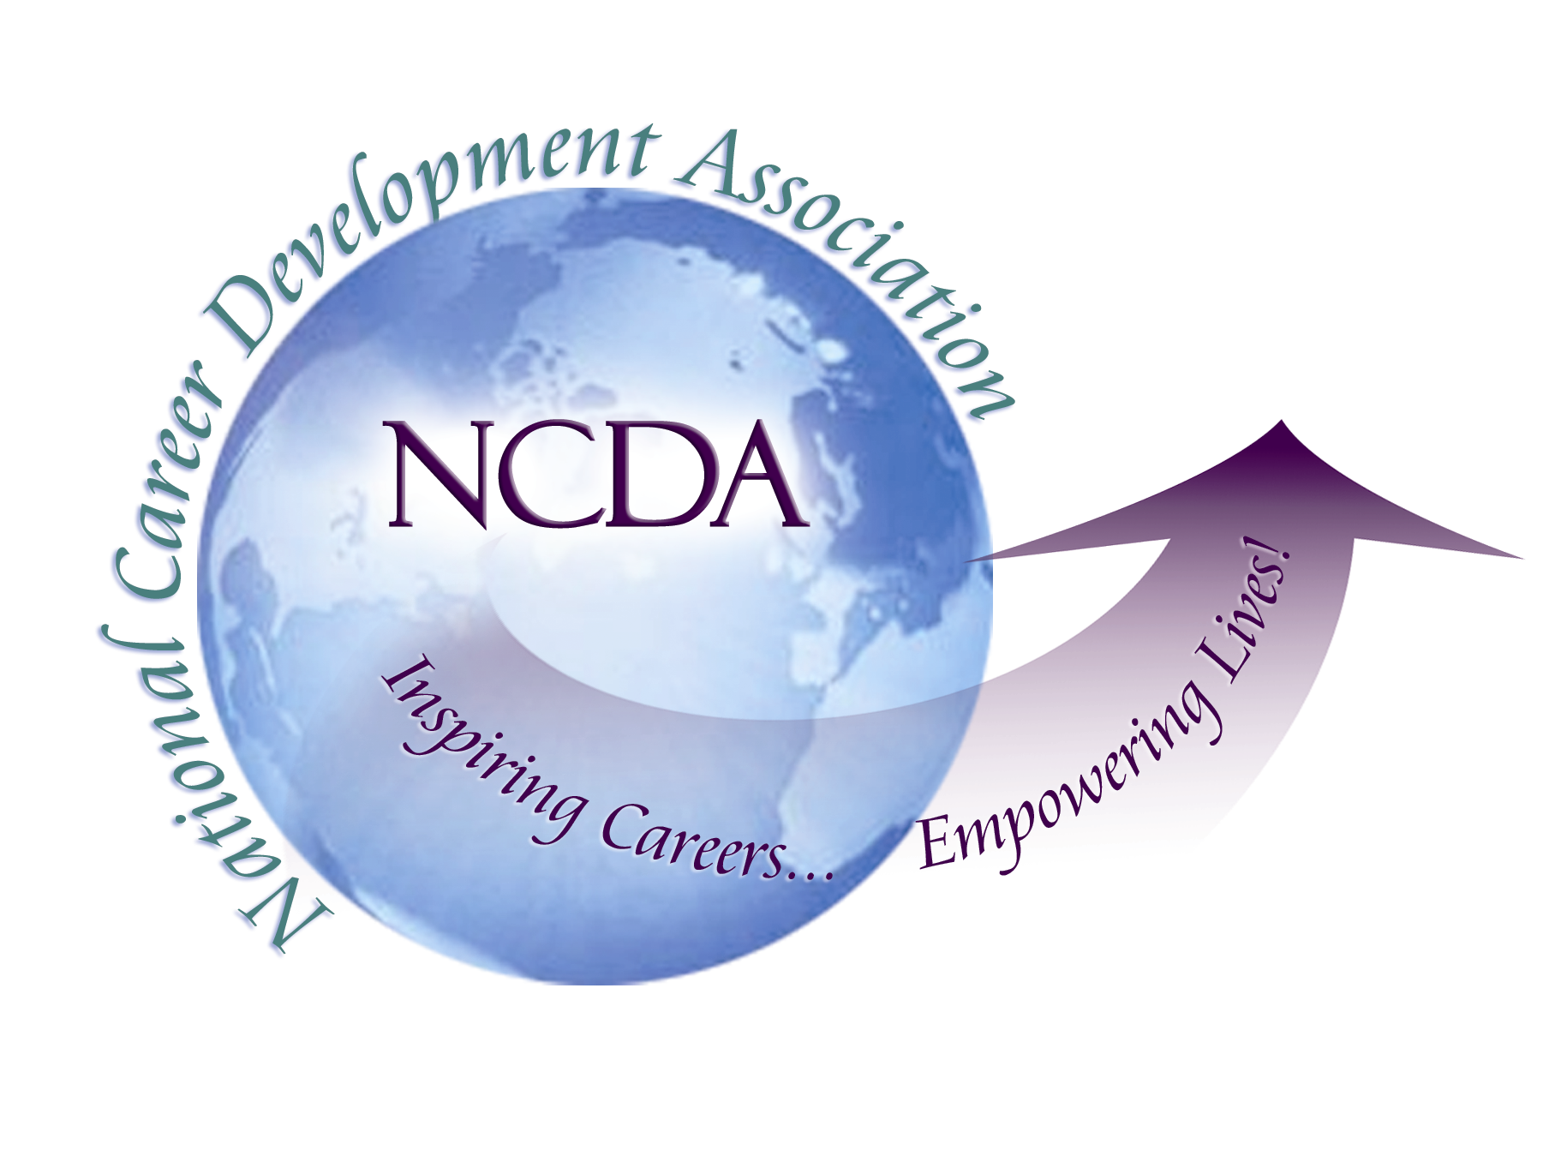
305 N. Beech Circle
Broken Arrow, OK 74012
918/663-7060
Fax: 918/663-7058
www.ncda.org

National Career Development Association
Leadership Academy
Action Learning Project Summary

Participant(s): Kevin Mellencamp and Jessica Wood

Board Mentor: Charles Lehman

Leadership Academy Class: 2016

Project Title: Next Step for Veterans

Project Description:

The purpose of the project was to better understand the career development needs of the veteran population via survey. A survey was also sent to college career services offices to gauge the services they provide to veterans. The goal of gathering data from these two groups was to provide a toolkit or resources and/or information to the career services centers in order to ensure a smooth transition from military to the world of work for the veterans.

Summary/Conclusion:

Here are some survey results from the college and university veteran career centers.

Findings were able to be gathered from 56 career services center participants.

Here are the results:

- A majority of the career services respondents were providing services to veterans.
  - Top services being provided are resume writing, career exploration and transferring military skills to the job market.
- About 50% of those surveyed do conduct special veteran outreach and have unique services that are useful including:
  - Financial planning, peer advising, specific recruiting events, mentoring, staff contacts, community outreach, services for families, virtual career fairs and networking events.
- Many indicated they did want more information on how to better serve this population in general.
  - Patterns of specific topics they wanted more information on were evident including connecting directly with jobs, aiding in transferring skills, transition to civilian world, and dealing with the disabilities or mental health challenges that can accompany a veteran.
The veterans’ survey was open for over 100 days and had 9 views, but no responses. Outreach efforts were completed to the Florida Student Veterans Associations (SVAs) and to NCDA members.

From Kevin’s perspective, it is not uncommon that no responses were received because military members being discharged are sent to a transition program for one or two weeks and they sometimes feel they have to go it alone after they are provided the information on educational benefits. The connection between the military member and the Transition Assistance Program (TAP) is not enough. TAP does not allow Colleges or Universities to provide input into the program.

Results/Recommendations:

Career counselors and other social services professionals want to be knowledgeable about
their client’s environmental challenges. This can help veterans find answers to eliminate barriers
to a successful job search. Research by Rubin (2012) suggests “most social work professionals
who will be assisting military personnel, veterans and their families know very little about this
population” (p. 294). Counselors will need to understand the importance of environmental
concerns on the returning veteran’s ability to find adequate civilian employment.
Rubin (2012) suggests: This includes preventing homelessness and rehabilitating those who are homeless; helping veterans and their families navigate through complex systems of care; helping
veterans secure employment, adequate housing, and veteran benefits related to education
and health care; and helping transitioning service members offset the loss of camaraderie
and cohesion by becoming involved in community activities and, thus, finding a new
"mission." (p. 295) Career counselors can do justice for the veteran when they are knowledgeable
and want to assist them in finding adequate civilian employment.

The voice of the veteran population needs to be heard, so increased surveying or other means to get answers on their needs is necessary. Even specific anecdotal stories could be helpful for this purpose.
On a personal note, I found it very difficult to find my way to my degrees after retirement.

Recommendations for career services professionals:
- Increased trainings and tools available
- Better understanding of veteran needs in general
- Forum to share the best practices already in existence

