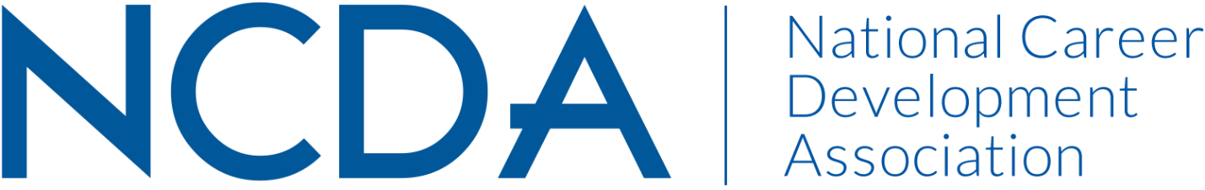

Annual Report 2022-2023

INTERNATIONAL STUDENT SERVICES COMMITTEE
Date of Report: September 14, 2023

Committee Members & Leadership
- 2022/2023 Co-chairs: Kelly Woods, krwoods@mtholyoke.edu & Ivette Mekdessi, ifm2@rice.edu
- 2023/2024 Co-chairs: Ellen Goldman, e.goldman@northeastern.edu) & Kelly Woods, krwoods@mtholyoke.edu
- 2022/2023 Members: Abby Senuty, Alexus D Garrett, Angela Tom, Ann-Marie Williams, Breanna Gallagher, Daniel Pack, Dr. Anupama Malik, Dr. Pankaj Desai, Elif Balin, Ellen Zold Goldman, Gaeun Seo, Hongshan Shao, Ivette Mekdessi, Jane Sitter, Jessica Schueller, June Hyun, Kelly Roberts, Kelly Woods, Leigh Mason, Lena Jackson, Lynette Hepburn-Richardson, Maggie Luo, Mitali Temurnikar, Paula Lazarim, Ruoci (Rosie) Shen, Sanaz Nabati, Sharena Payne, Xi Zhang, Yangyang Liu, Yuleinys Castillo, Yuliia Sobko, Zhiqi Liu

Committee Activities to Date
- Six general meetings and more than 40 sub-team meetings were held. The sub-teams include the Social Media Team, the Research Team, the Resources Team and the Mini-Conference Team.

- Two leaders of the committee (Kelly Woods and Ivette Mekdessi) presented at the 2023 NCDA conference about our conference committee.

- Several members of the Committee presented at the 2023 NCDA conference regarding career development and International Students.

- The Mini-Conference Team hosted the fourth annual ISSC Mini-Conference on August 4, 2023. 63 members registered to attend this conference with 5 presentations and a membership chat. 8 were granted continuing education hours. The theme of the conference was “The Future of Work: Navigating Global Opportunities and Mobility for International Students”. The mini-conference team met seven times to plan the event.

- The Social Media Team focused on serving career development professionals with avenues to exchange ideas, resources, best practices, programs, recommendations, and innovations for working with international students and employers. The team has grown the YouTube channel to now have 75 subscribers and 12 videos. The ISSC LinkedIn Group’s strategic engagement enabled the group’s growth to 1020 members. Thanks to the budget provided by NCDA, our team was able to hire a freelance video editor to support our Youtube video publication. The Social Media Team chairs collaborated to host a webinar on June 9, 2023 about International Student Career Development in Focus: Learn from Past NCDA ISSC Co-Chairs.

- The Research and Writing Team presented virtually at the 2022 NCDA conference on Cultivating Career Adaptability and Resilience: Cross-Cultural and Global Justice Perspectives; edited the manuscript for the research project on multicultural, social justice, and advocacy competencies; collaborated with The Resources Team to update NCDA ISSC Resource Guide research section; finalized the YouTube video project based on past research results and implications; and conducted a new qualitative research project on international students’ career development and needs, IRB pending submission.

- The Resources Team clarified when and how to refer to the career guide when members cite resources from the guide; developed new strategies and timeline for the upcoming 2023-2024 resource guide update in order to make more effective and efficient without using too much burdens on team leads and members; and compiled relevant career articles and resources that can be added to the 2023-2024 resource guide.

