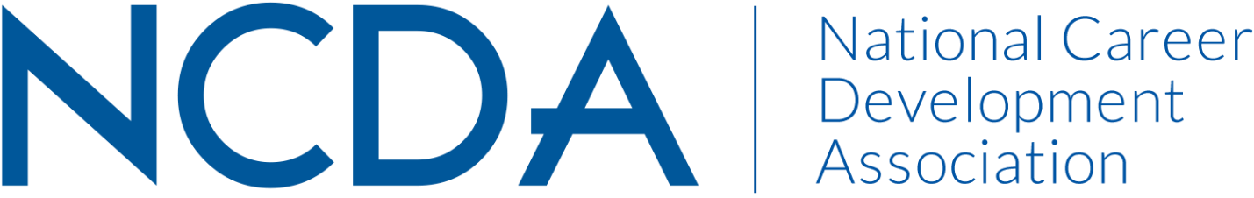

***Annual Report***

**MEMBERSHIP COMMITTEE**

**September 4, 2024**

Committee Co-Chairs:

* Dr. Mary Edwin ([edwinmo@umsl.edu](mailto:edwinmo@umsl.edu))
* Dr. Heather Robertson ([robertsh@stjohns.edu](mailto:robertsh@stjohns.edu))

List Committee Members (no contact information required)

* Emily Gomez ([egomez@hireheroesusa.org](mailto:egomez@hireheroesusa.org))

**Activities to Date**

Since mid-year report:

* Received contact from two new members with interest in NCDA Membership Committee: Kimberly Carothers and Delasia Rice; included in 8/24/2024 meeting
* Conducted a NCDA Membership Committee Meeting on August 27, 20224, with plans to continue membership drive in 2025 and meet with NCDA liaison to review prior membership committee idea and efforts

**Projected Plan through fiscal year end (September 30th)**

* Co-chairs to meet with NCDA liaison to review prior ideas and efforts
* Schedule another meeting of NCDA membership committee for fall 2024

If you received funding for your work, what specific outcome(s) benefited NCDA? N/A – no funding received