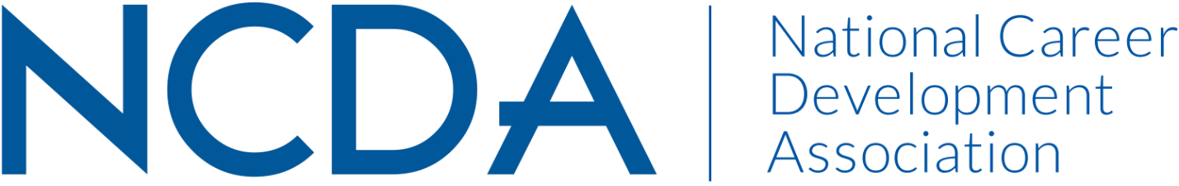

**NATIONAL CAREER DEVELOPMENT MONTH COMMITTEE**

**September 1, 2024**

Kymmie Cartledge (Co-Chair): kcartledge@lexington1.net

Cornelius Thomas (Co-Chair): corneliusthomas@johnston.k12.nc.us

Logann Todd

Meredith Brown

Alix Ruby

**Activities to Date**

* Updated brochure for the new theme
* Podcast episode for NCD month.
* Lesson plans for all grade levels related to the contest theme
* Social media toolkit for contest advertisement
* The revised national judging process
* judge submissions (March/April)
* Notify state coordinators, contest participants, and NCDA members of winners (May)
* Send prizes to winners (May)
* Secure contest theme and update brochure for the upcoming contest prior to NCDA

Conference in June (before June)

* Published Article for NCD Month in Career Developments Magazine
* Trained a new state contact for Missouri

**Projected Plan through fiscal year end (September 30th)**

* Curate resources for career development professionals (K-12 specifically) and create
* connections to the theme of the poetry and art contest and the National Career Development Month (ongoing)
* Develop a possible podcast episode for November 2024